**Protein-protein interaction analysis of genes and proteins involved in neuropathy**

Network analysis was performed for genes falling into three distinct categories: those associated with oxaliplatin-induced peripheral neuropathy, genes associated with sodium channels in the context of oxaliplatin-induced peripheral neuropathy, and proteins linked with oxaliplatin-induced peripheral neuropathy.

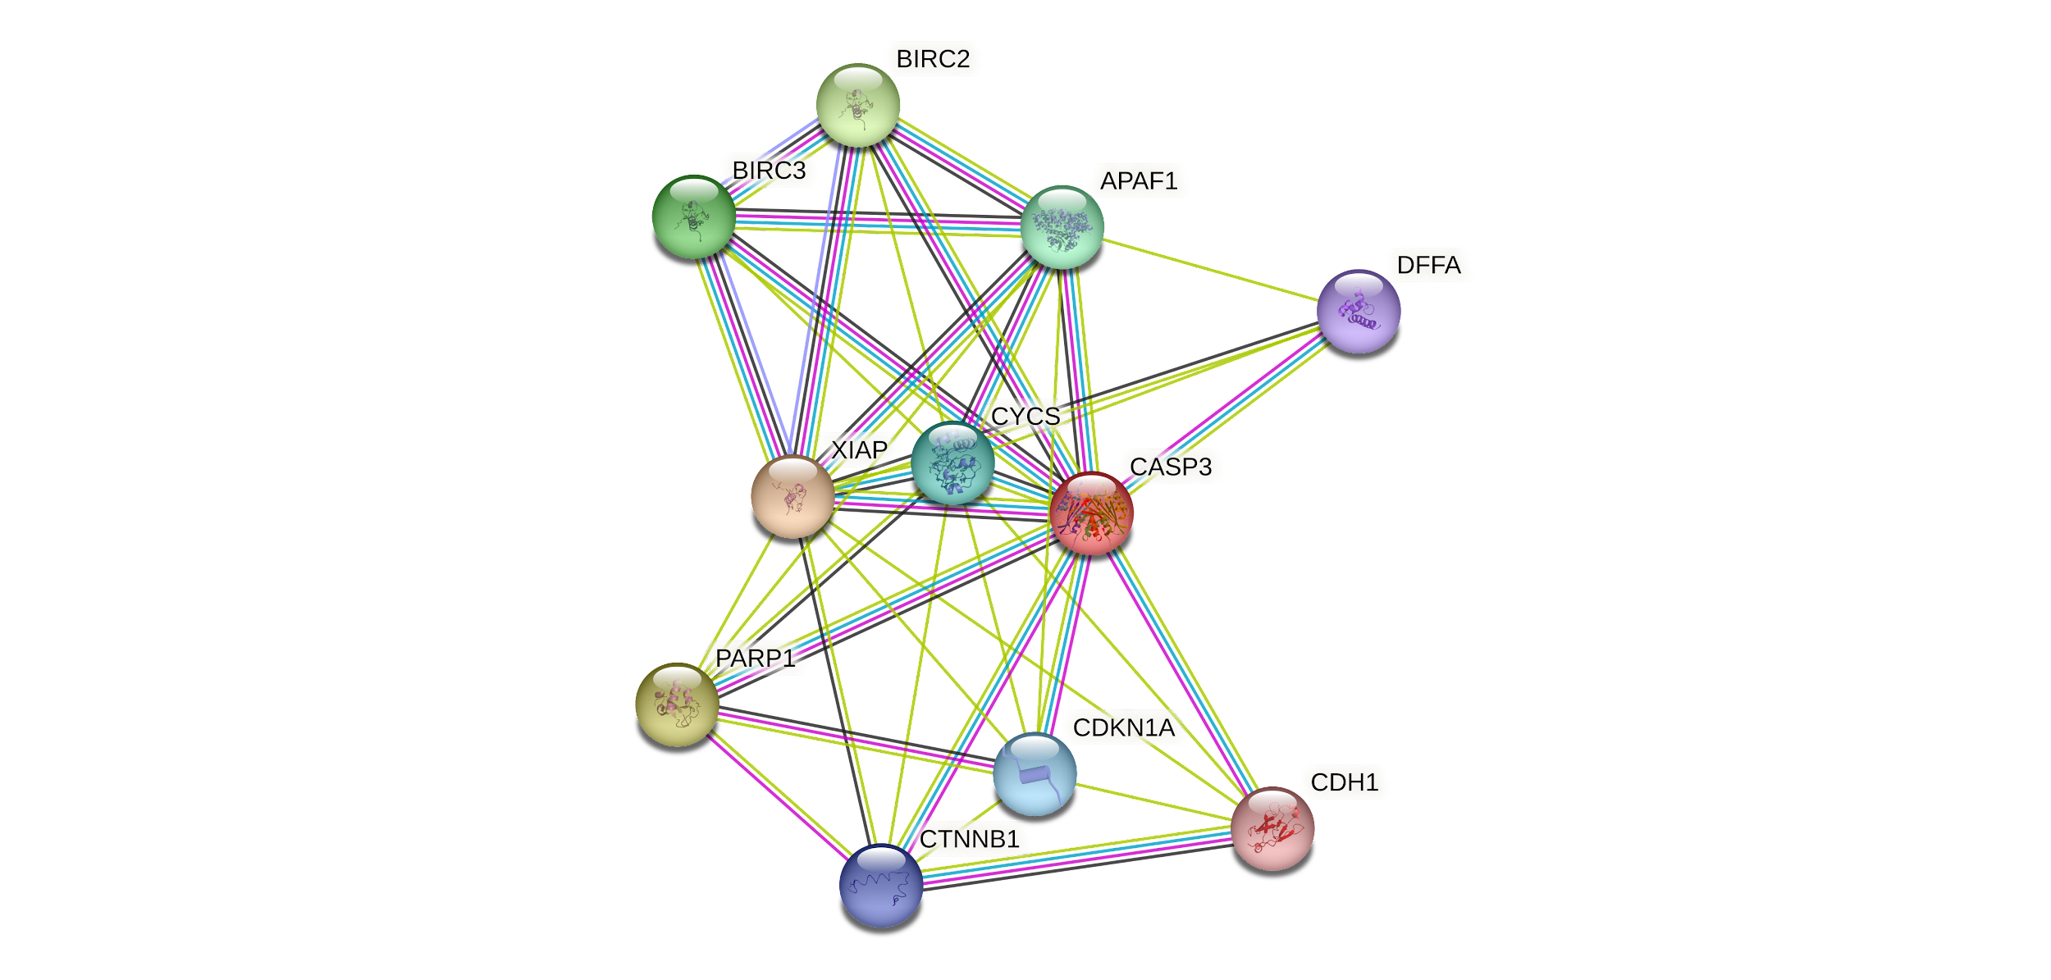

**Figure S1:** Protein-protein interactions of CASP3 using STRING database

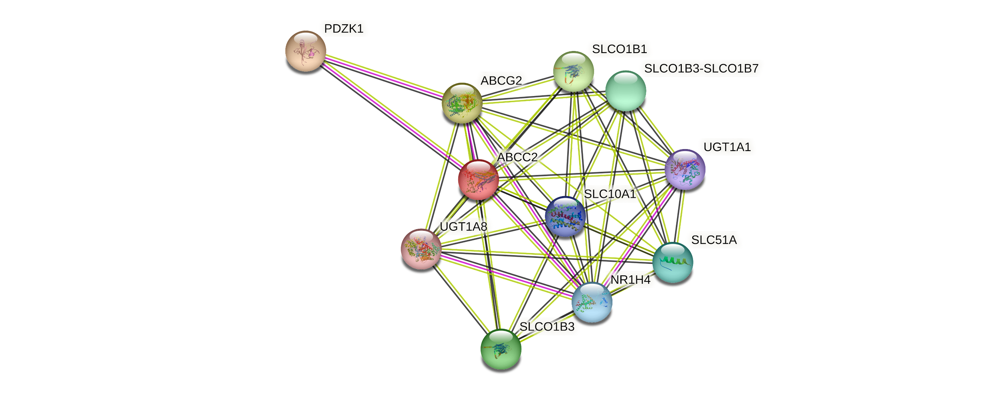

**Figure S2:** Protein-protein interactions of ABCC2 using STRING database

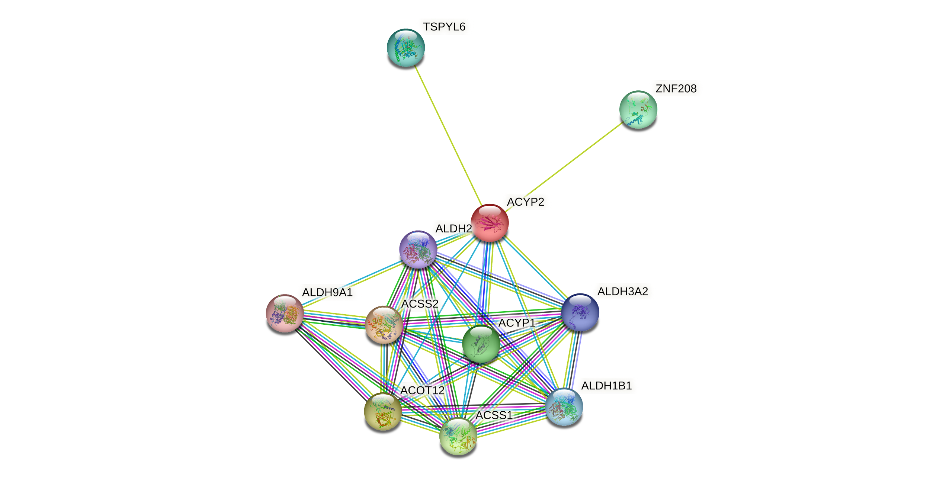

**Figure S3:** Protein-protein interactions of ACYP2 using STRING database

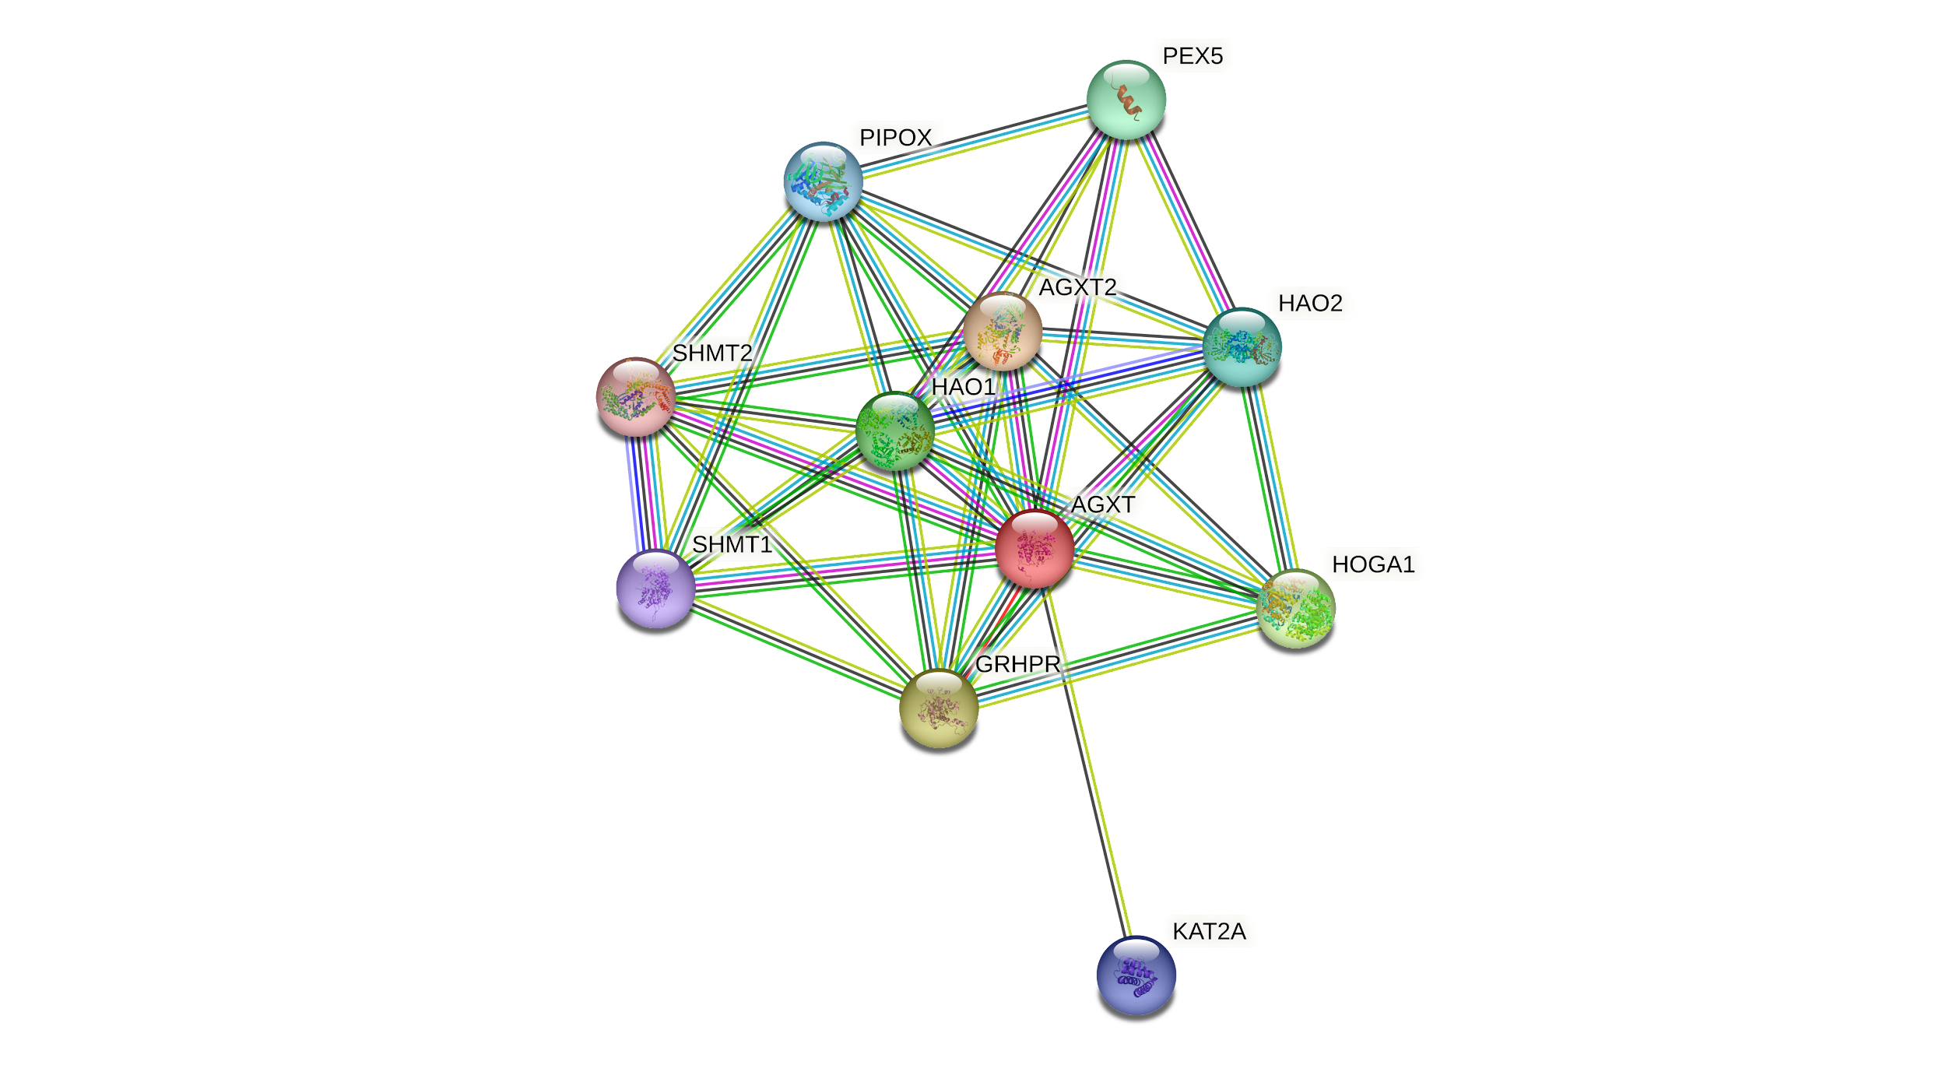

**Figure S4:** Protein-protein interactions of AGXT using STRING database

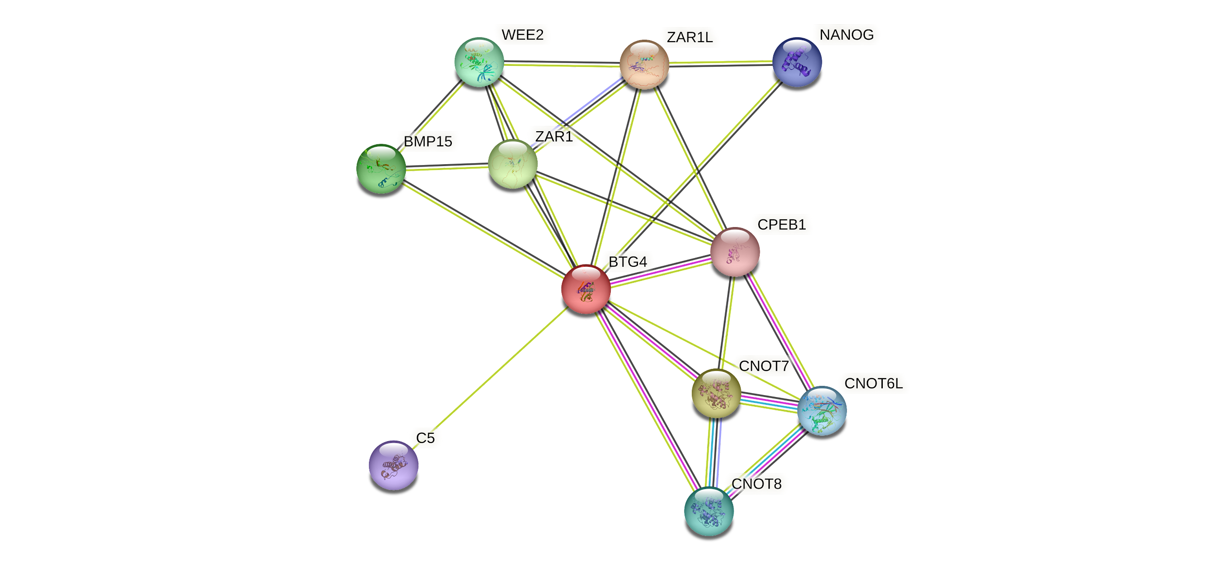

**Figure S5:** Protein-protein interactions of BTG4 using STRING database

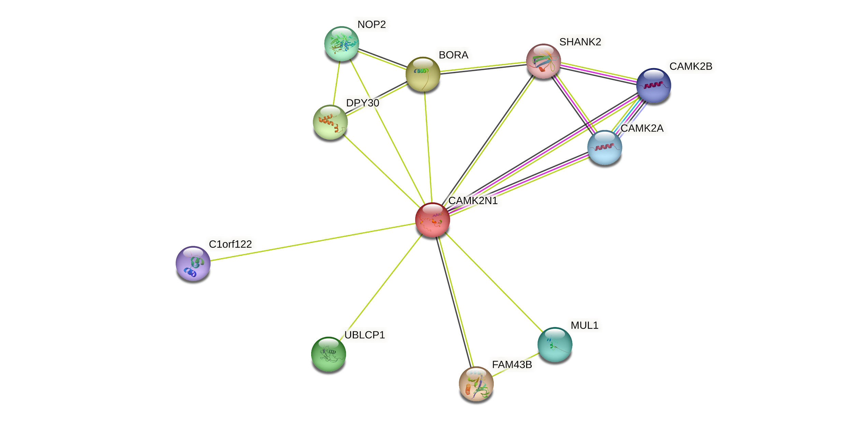

**Figure S6:** Protein-protein interactions of CAMK2N1 using STRING database

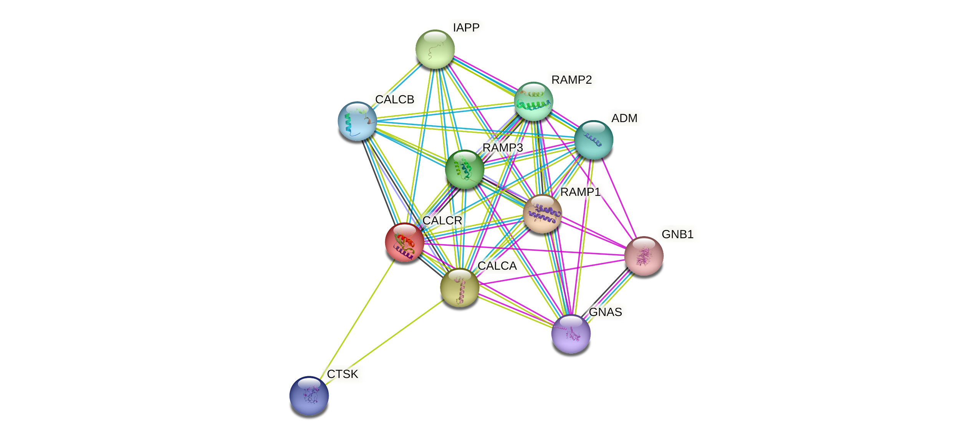

**Figure S7:** Protein-protein interactions of CTR1 using STRING database

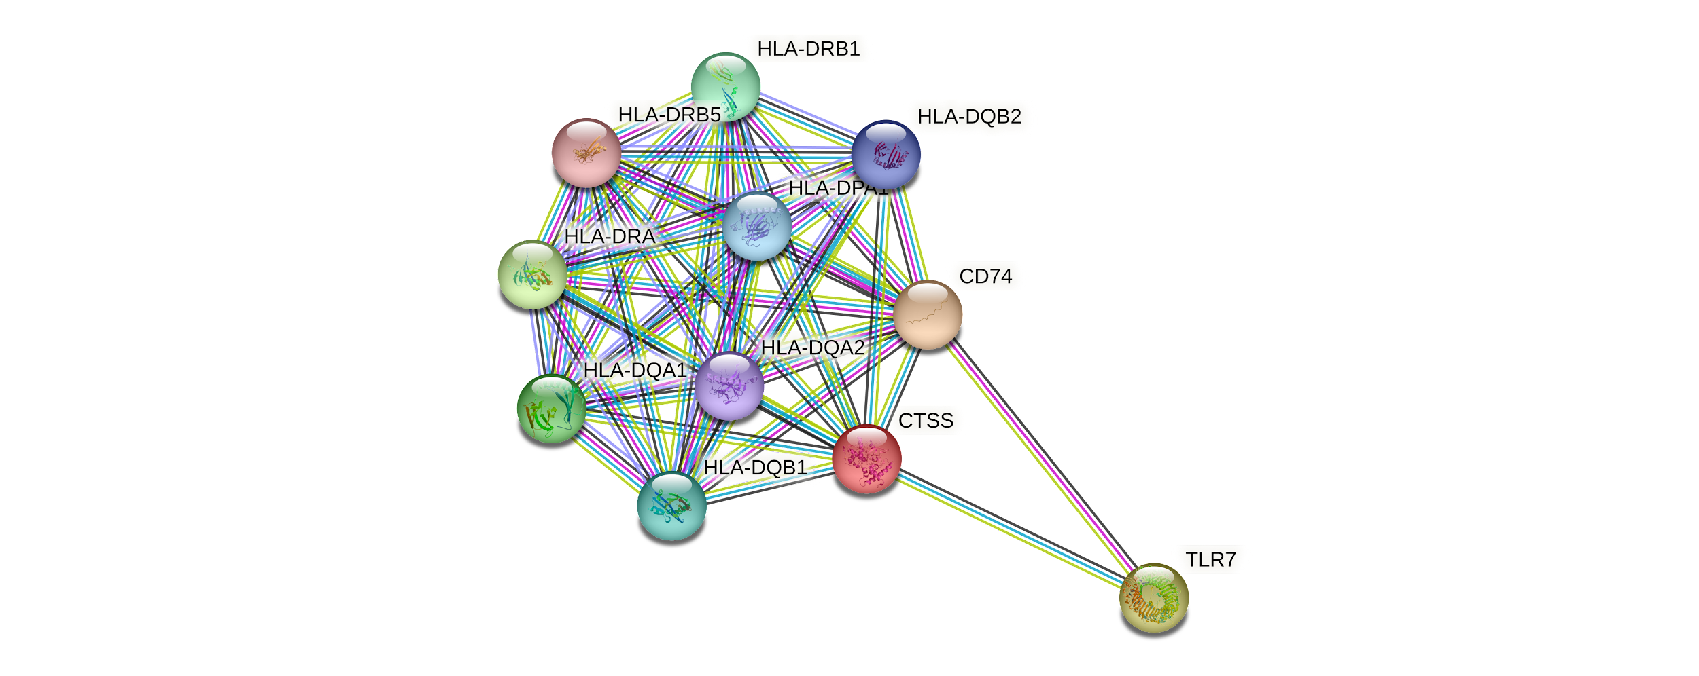

**Figure S8:** Protein-protein interactions of CTSS using STRING database

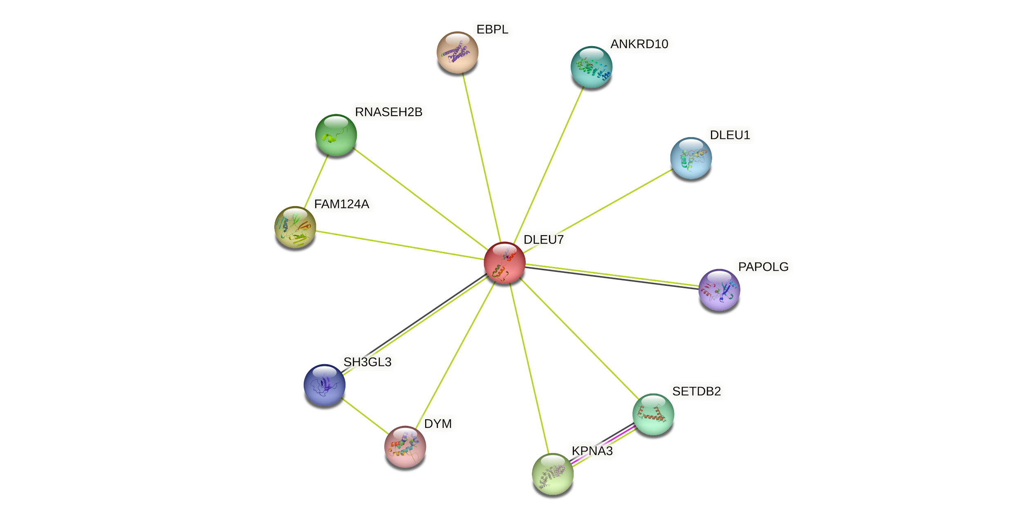

**Figure S9:** Protein-protein interactions of DLEU7 using STRING database

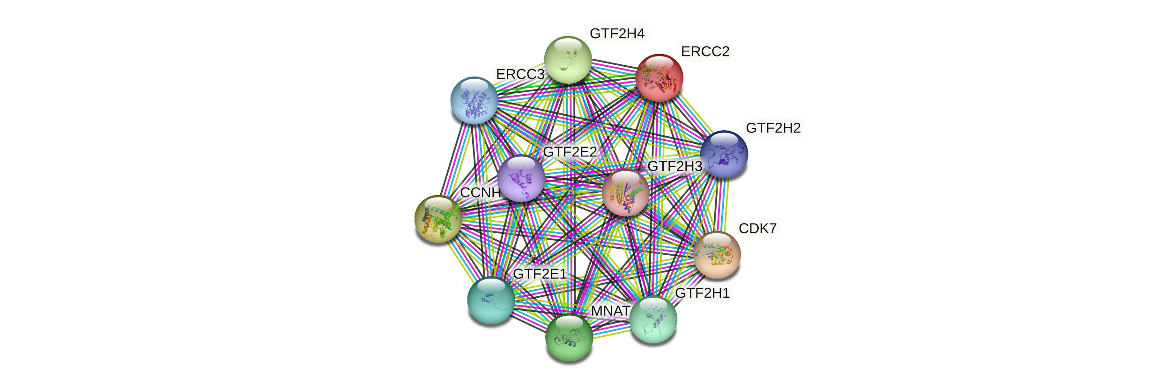

**Figure S10:** Protein-protein interactions of ERCC2 using STRING database

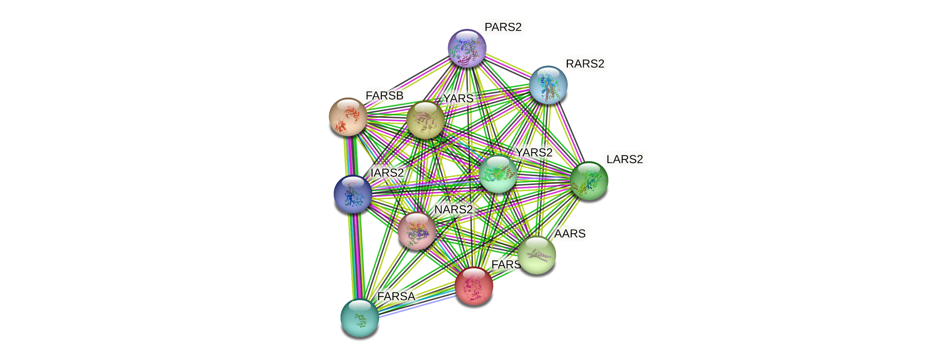

**Figure S11:** Protein-protein interactions of FARS2 using STRING database

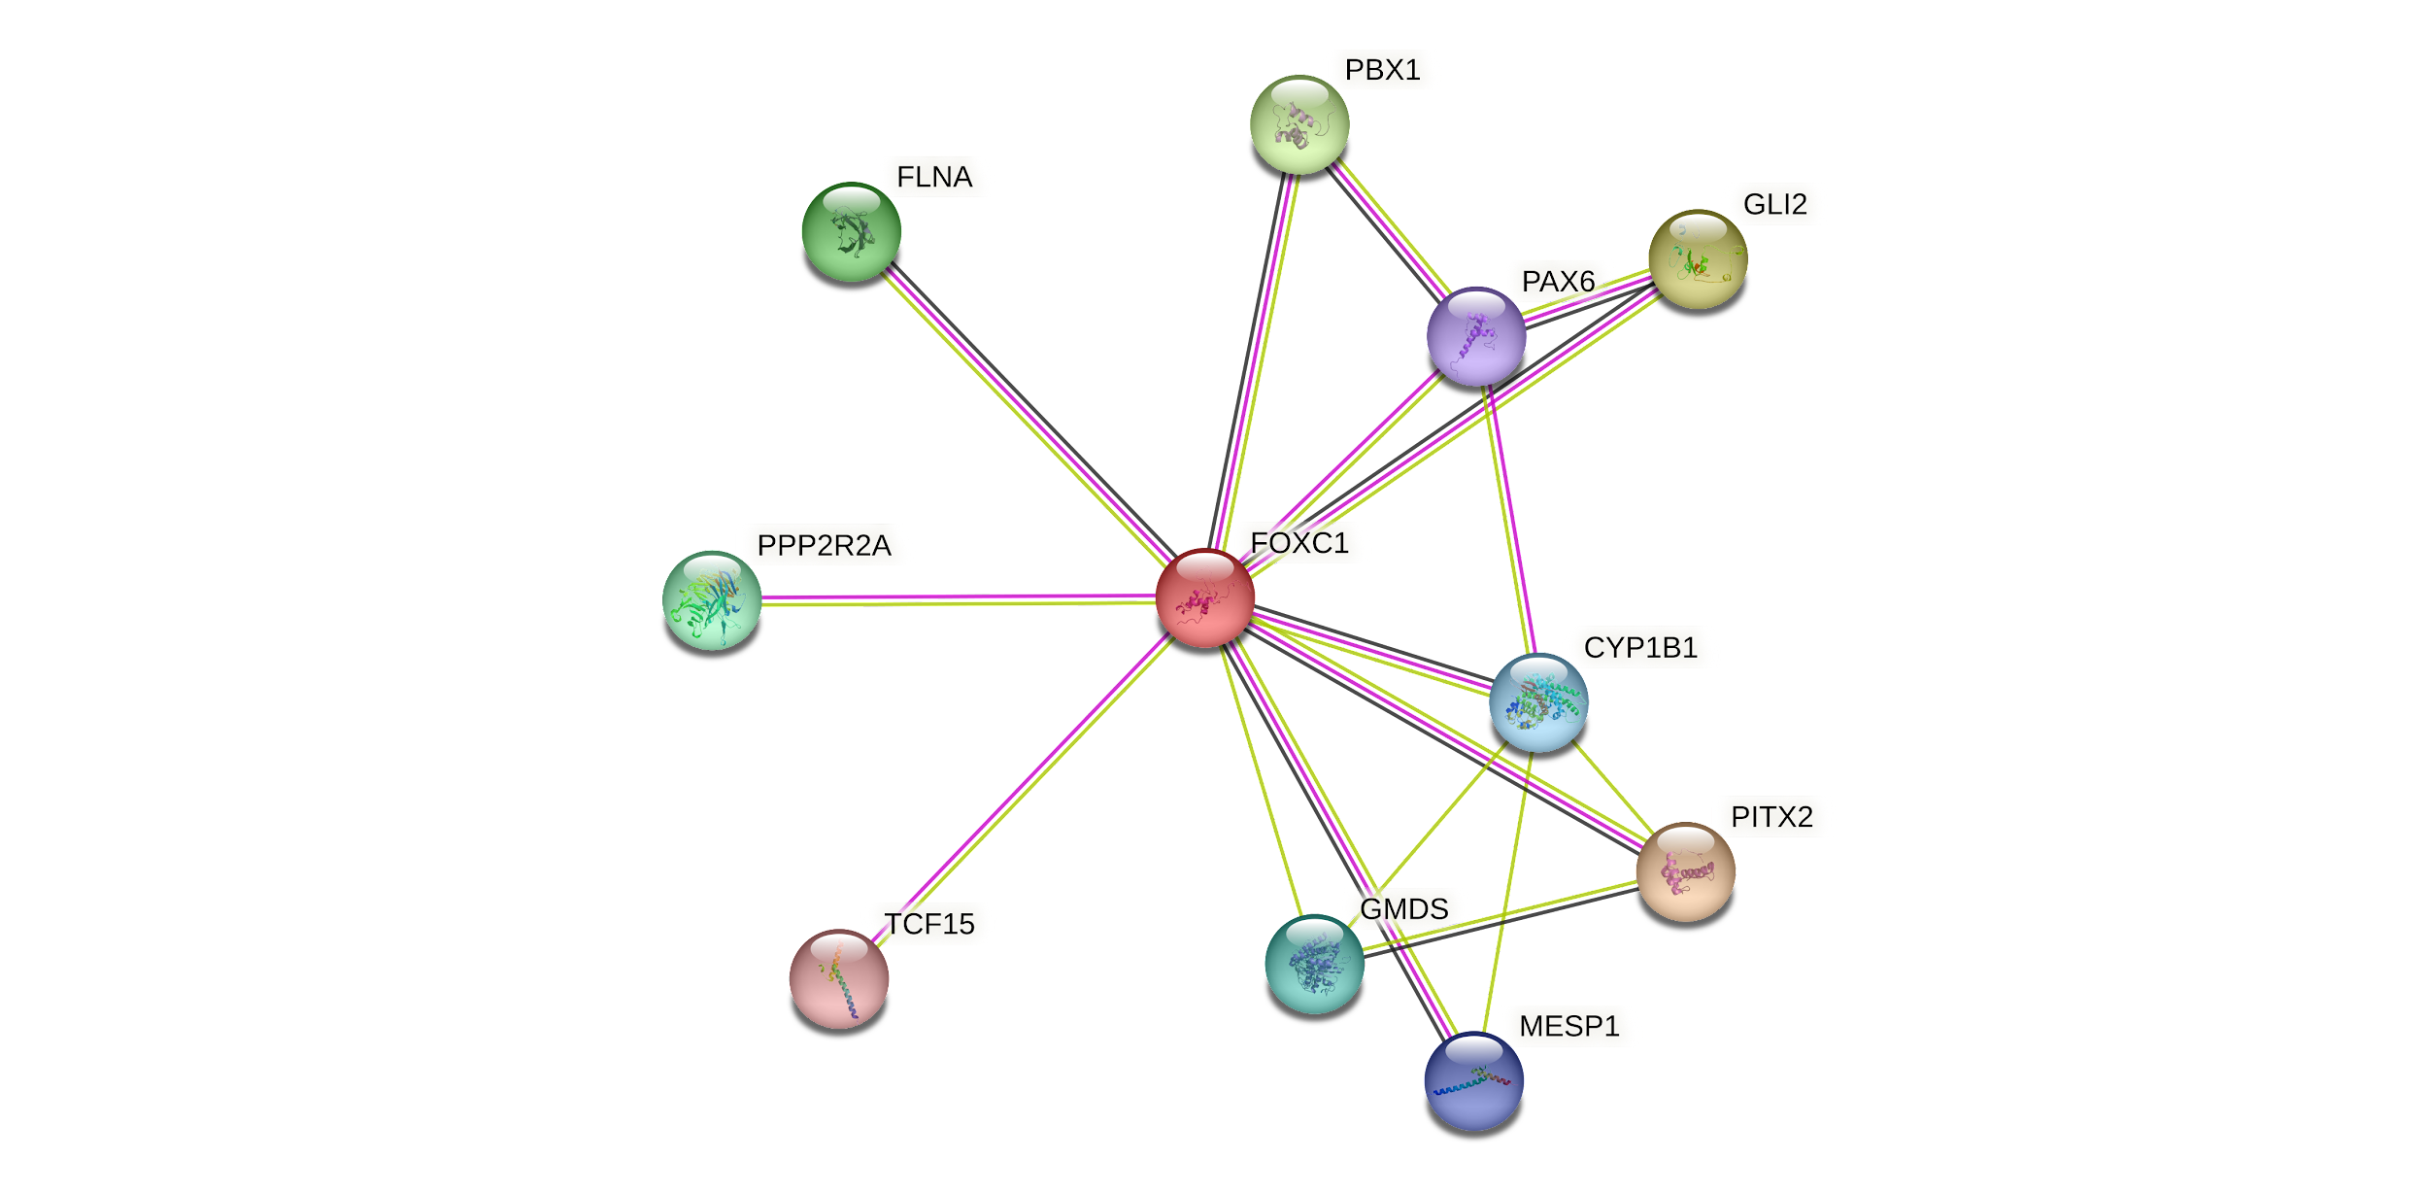

**Figure S12:** Protein-protein interactions of FOXC1 using STRING database

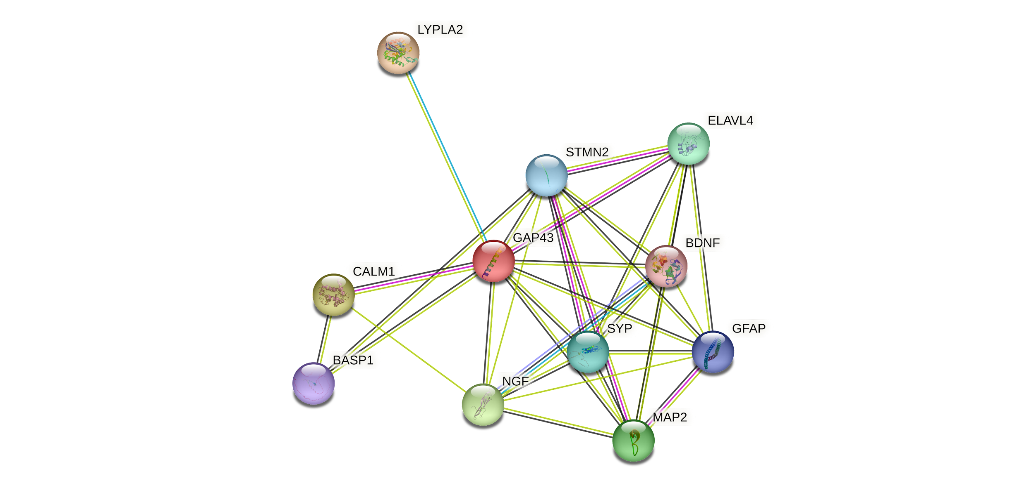

**Figure S13:** Protein-protein interactions of GAP43 using STRING database

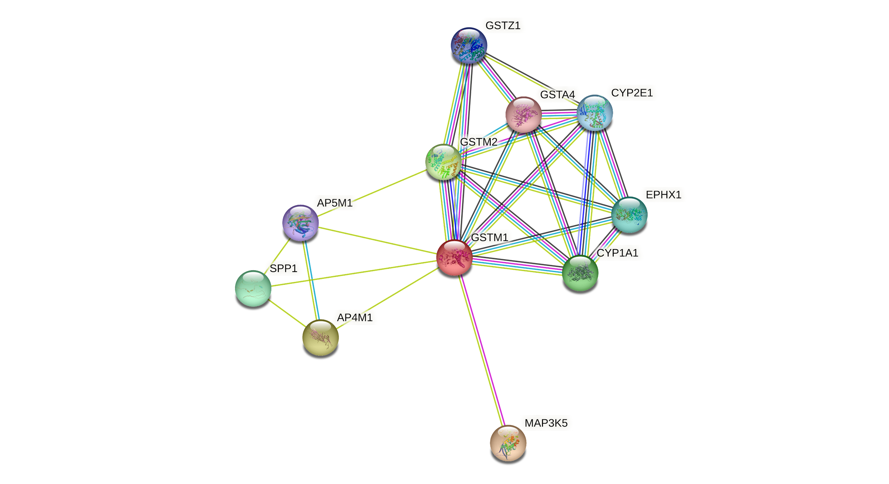

**Figure S14:** Protein-protein interactions of GSTM1 using STRING database

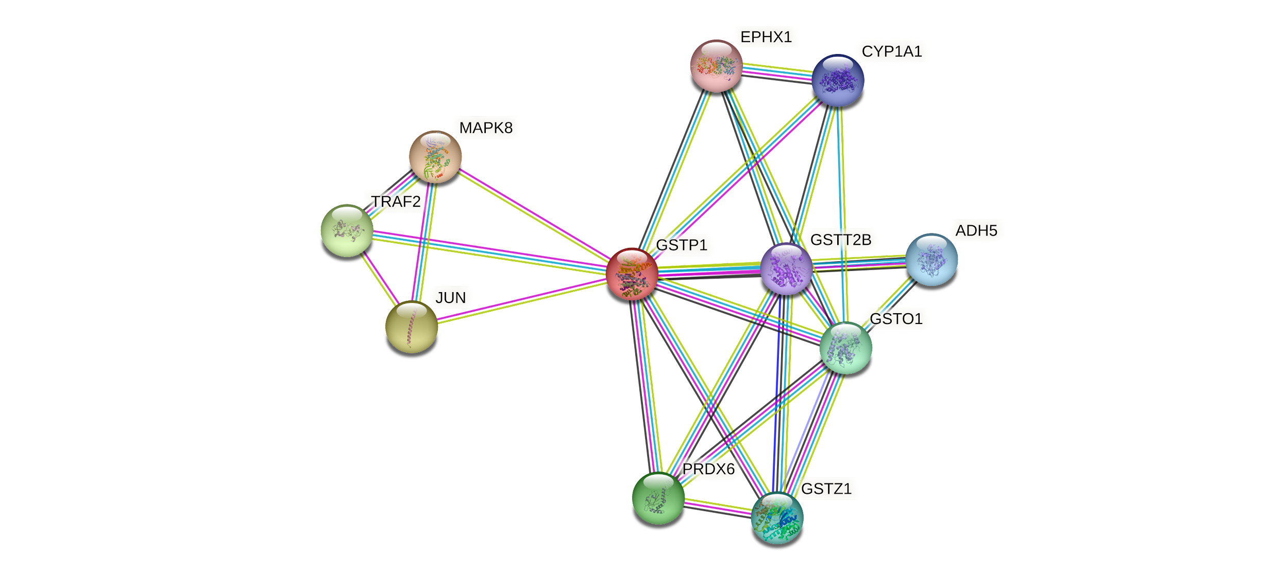

**Figure S15:** Protein-protein interactions of GSTP1 using STRING database

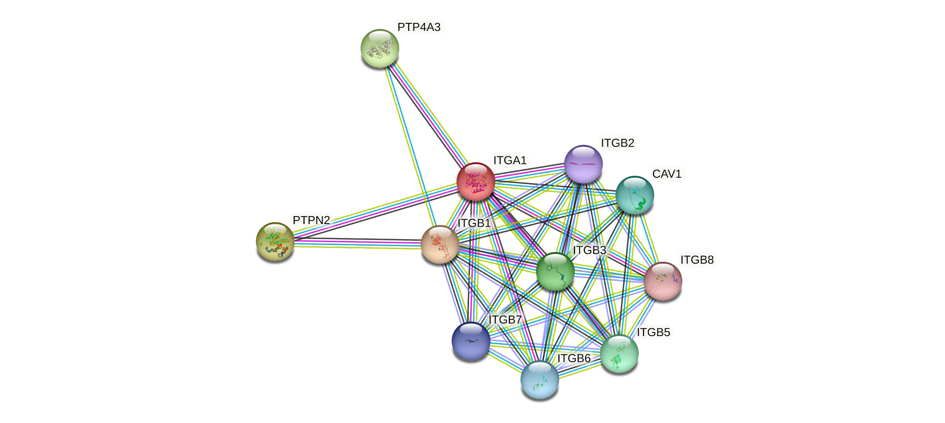

**Figure S16:** Protein-protein interactions of ITGA1 using STRING database

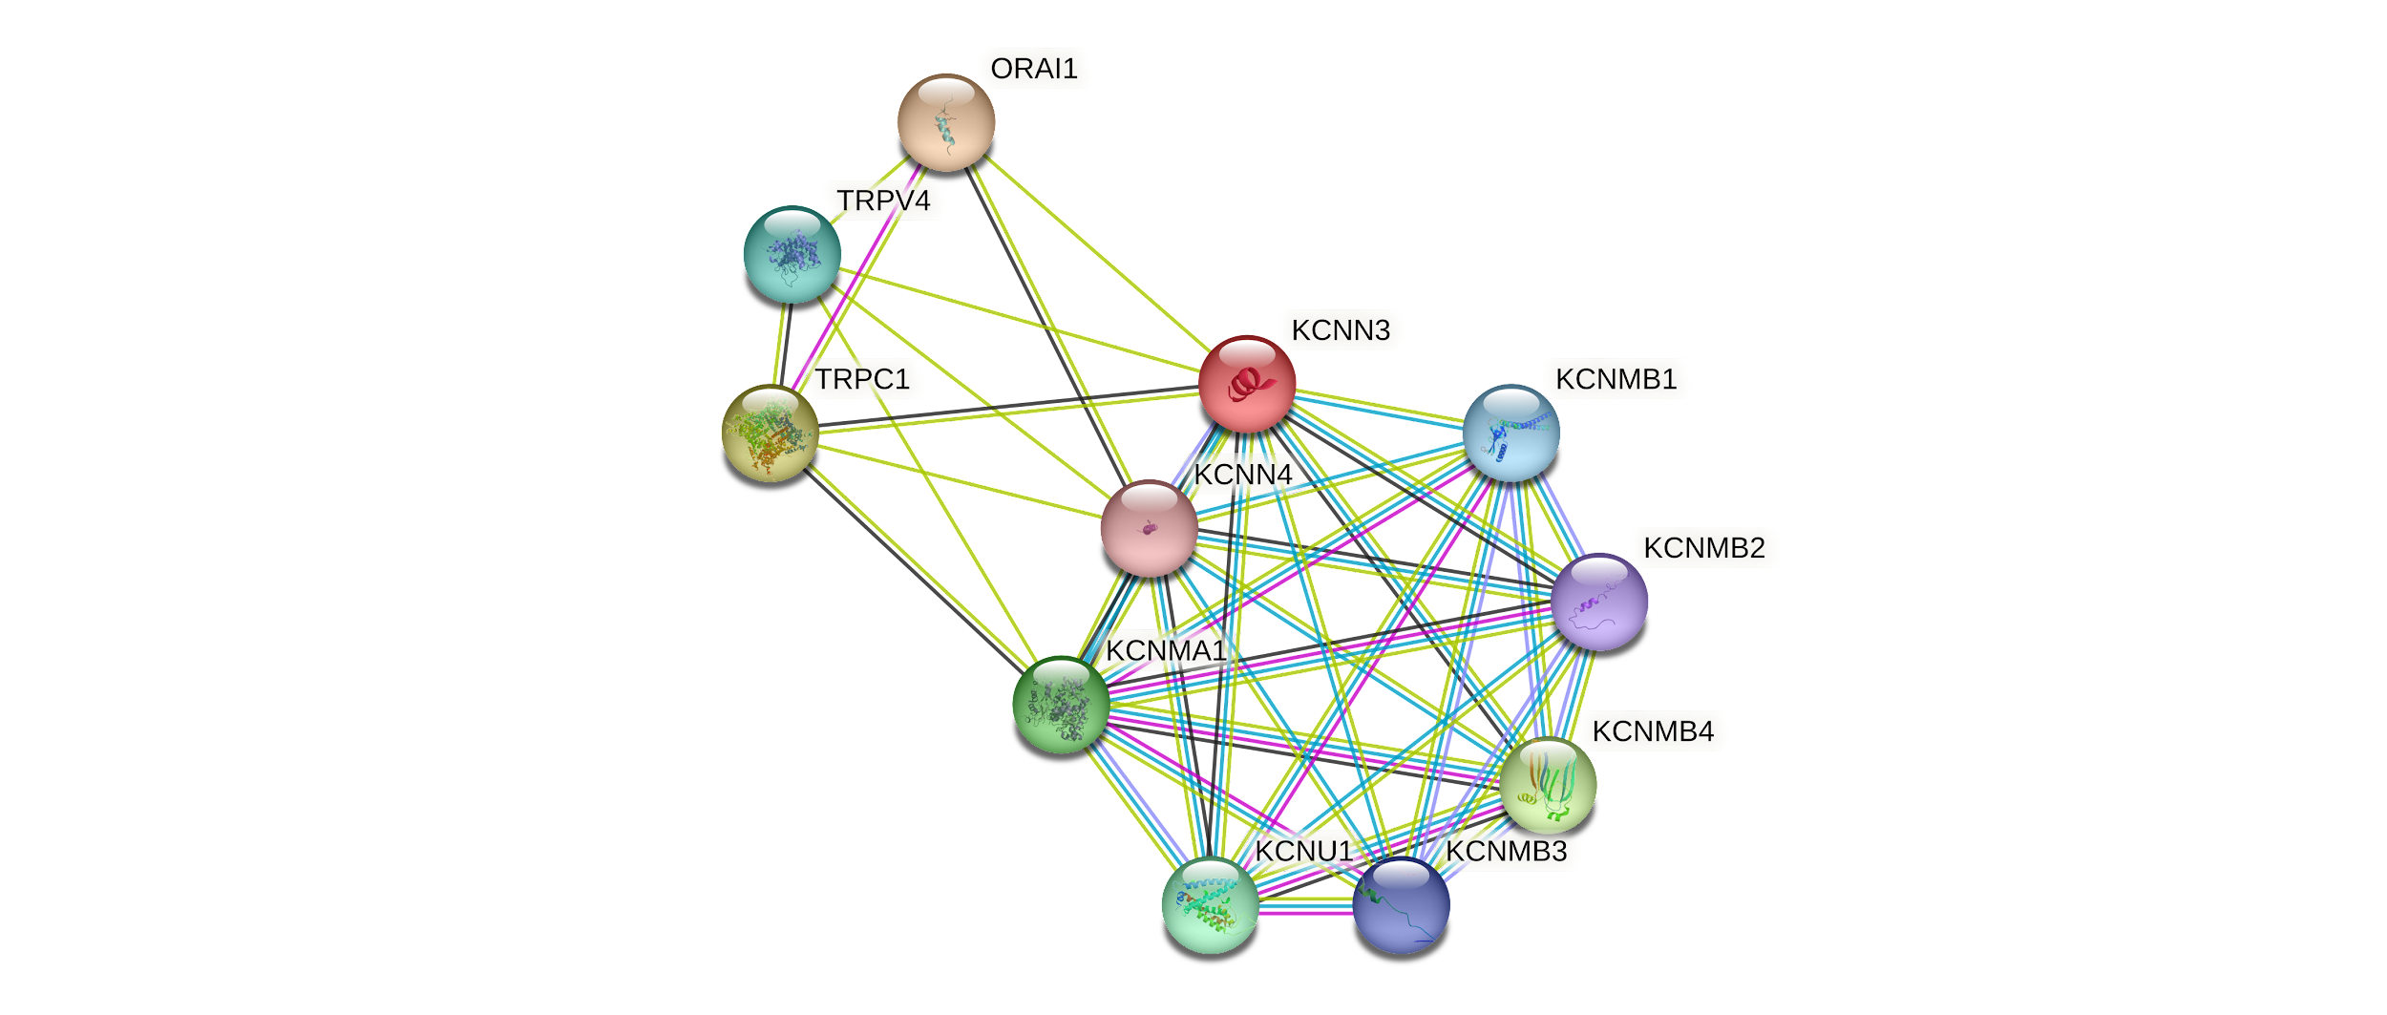

**Figure S17:** Protein-protein interactions of KCNN3 using STRING database

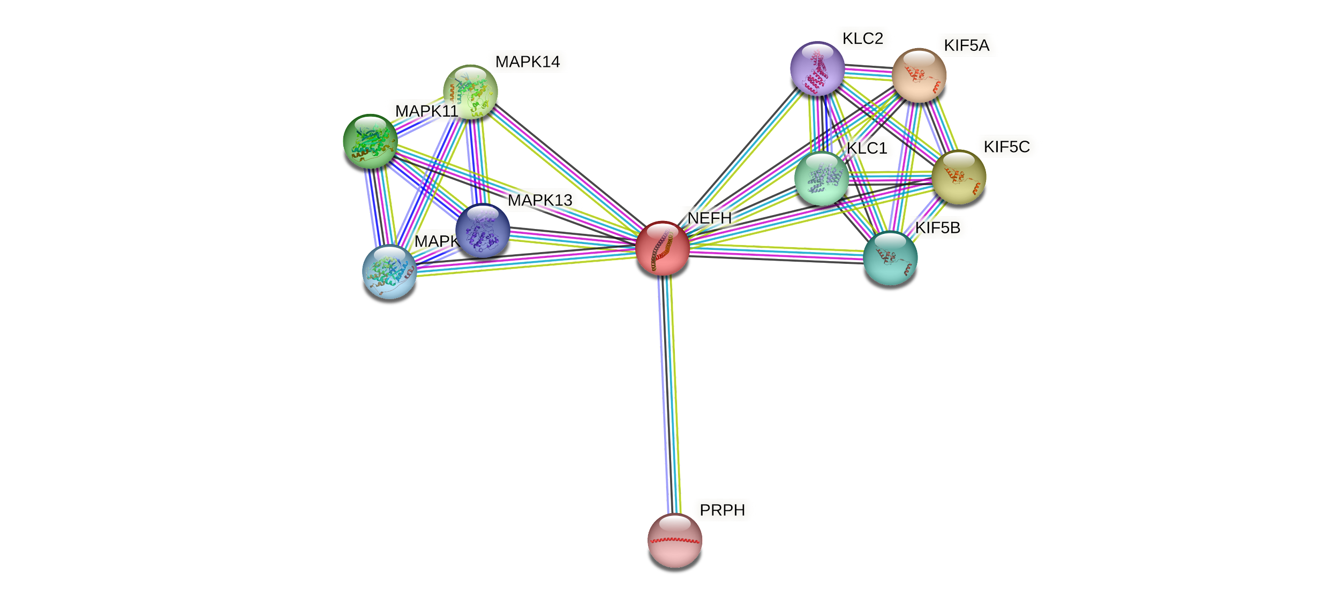

**Figure S18:** Protein-protein interactions of NEFH using string database

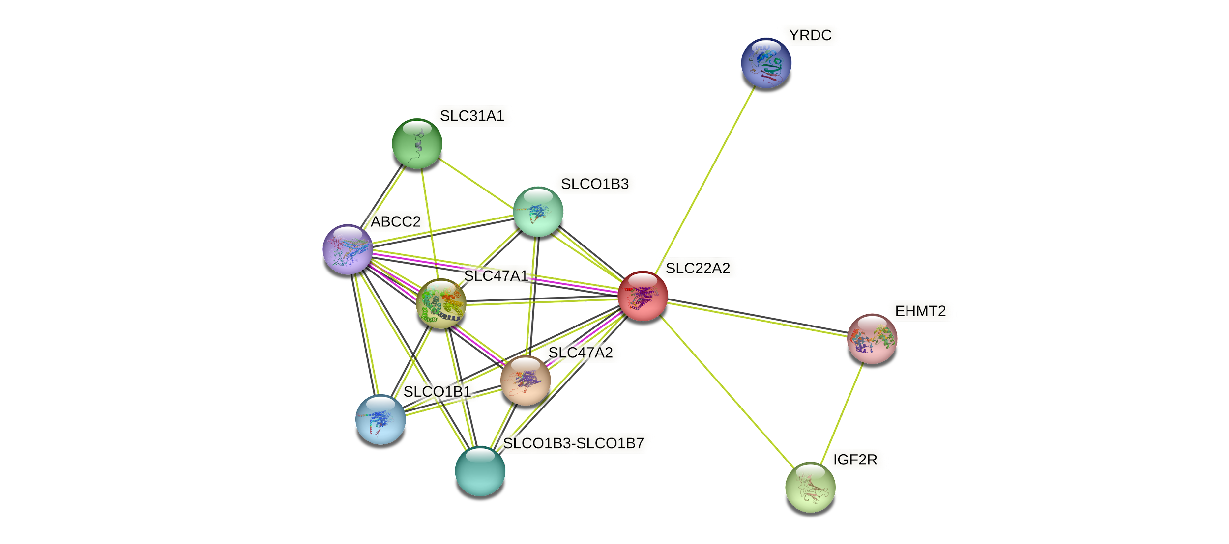

**Figure S19:** Protein-protein interactions of OCT2 using STRING database

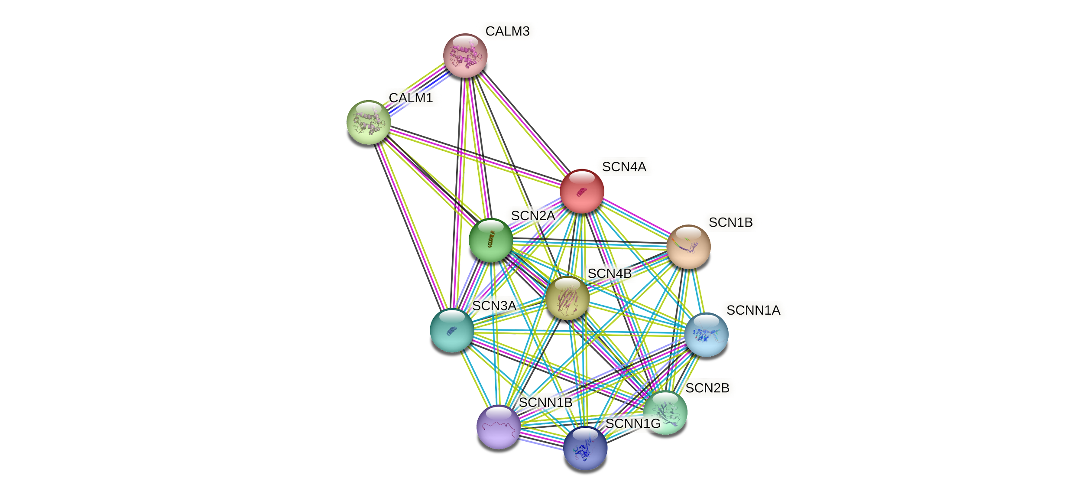

**Figure S20:** Protein-protein interactions of SCN4A using STRING database

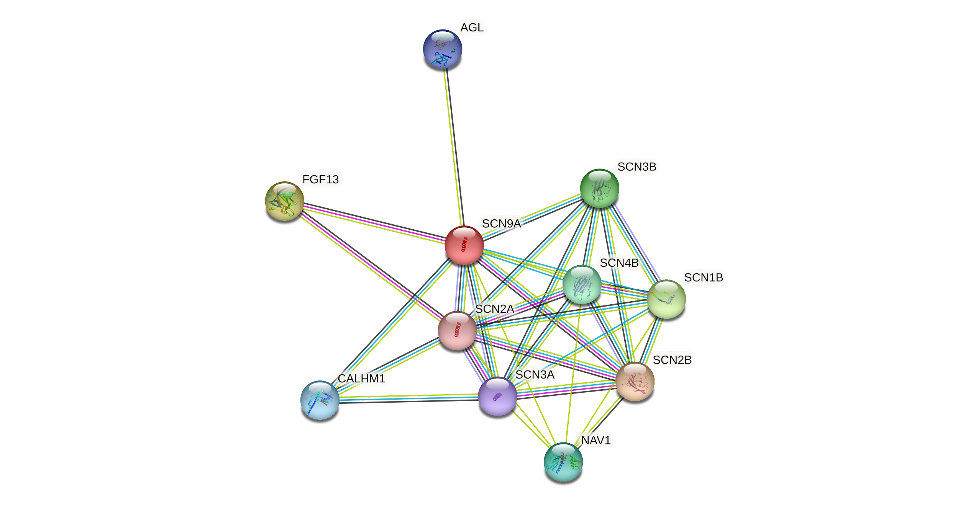

**Figure S21:** Protein-protein interactions of SCN9A using STRING database

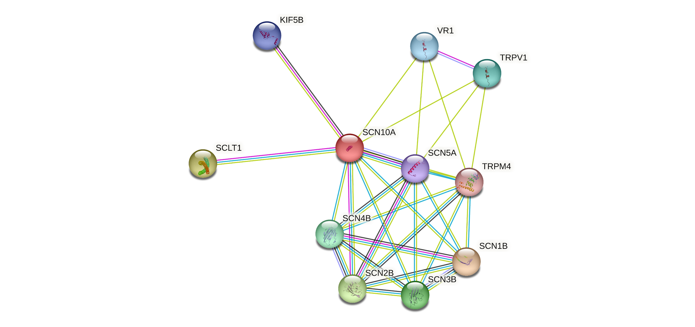

**Figure S22:** Protein-protein interactions of SCN10A using STRING database

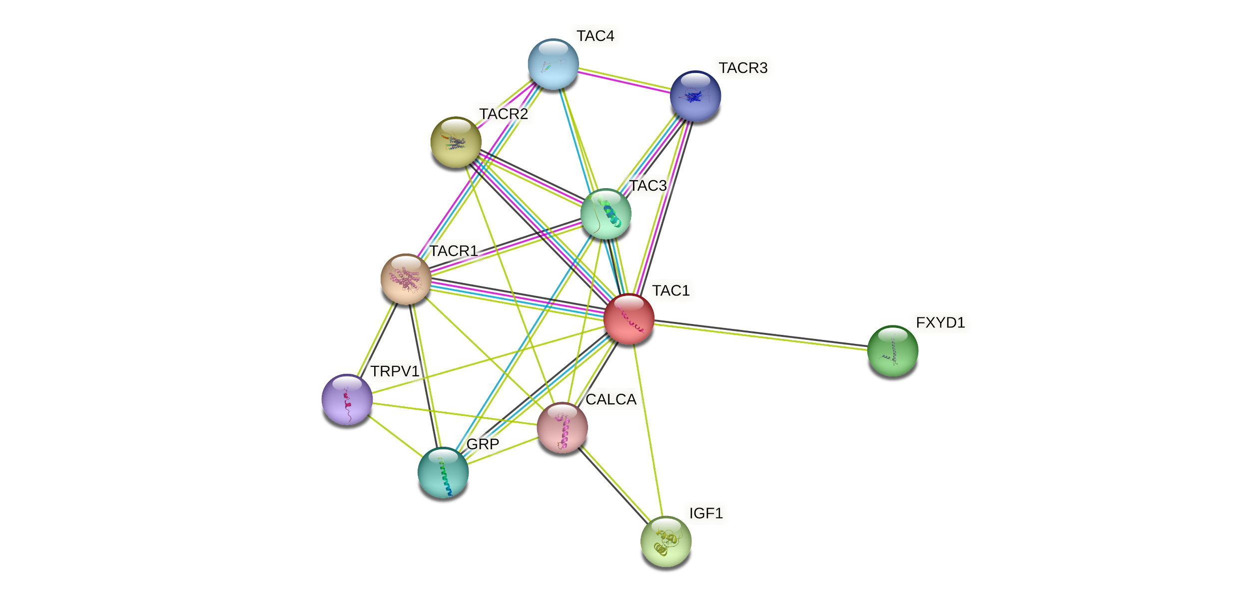

**Figure S23:** Protein-protein interactions of TAC1 using STRING database

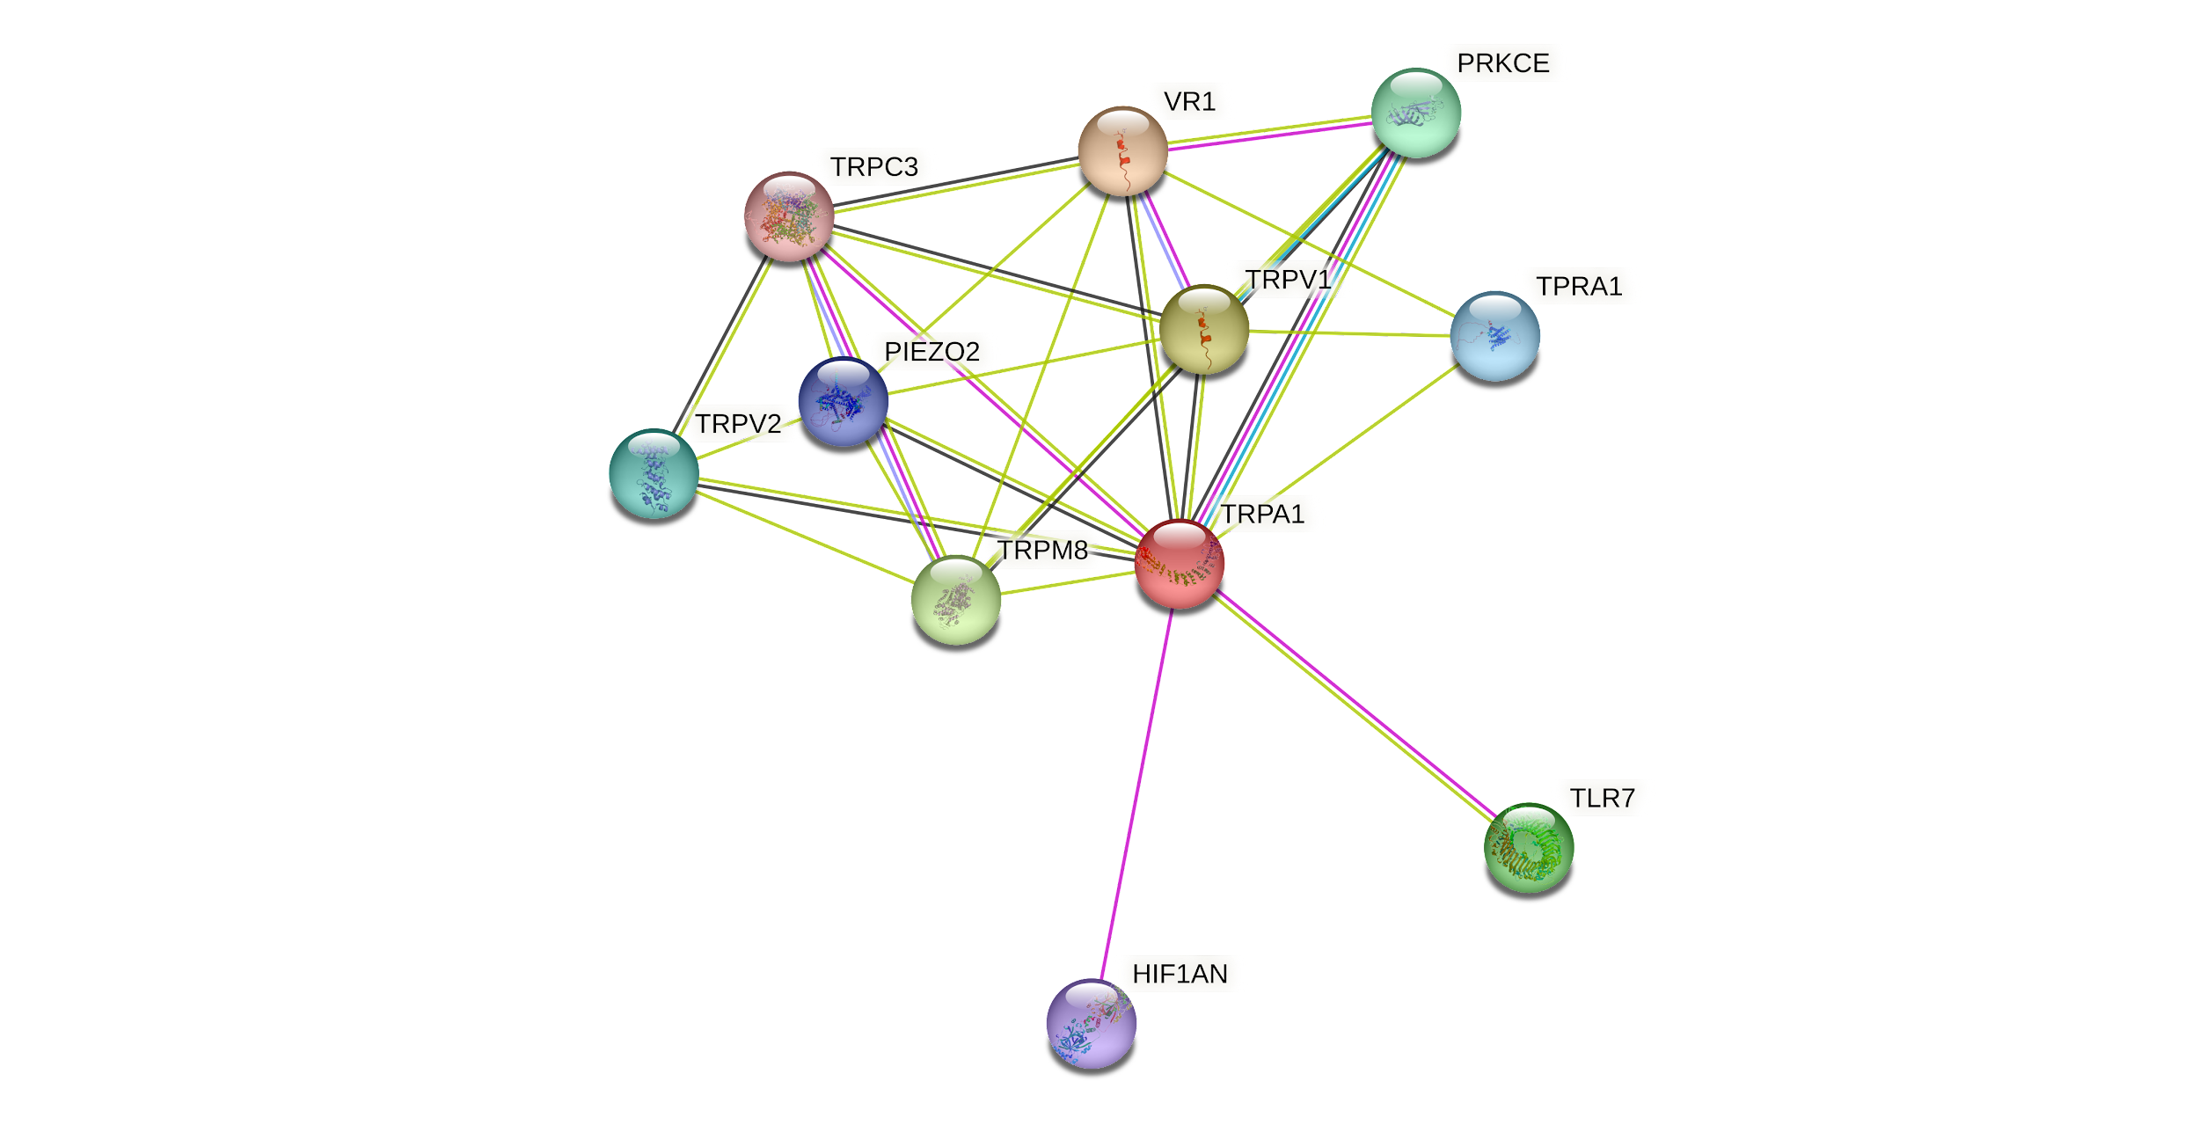

**Figure S24:** Protein-protein interactions of TRPA1 using STRING database

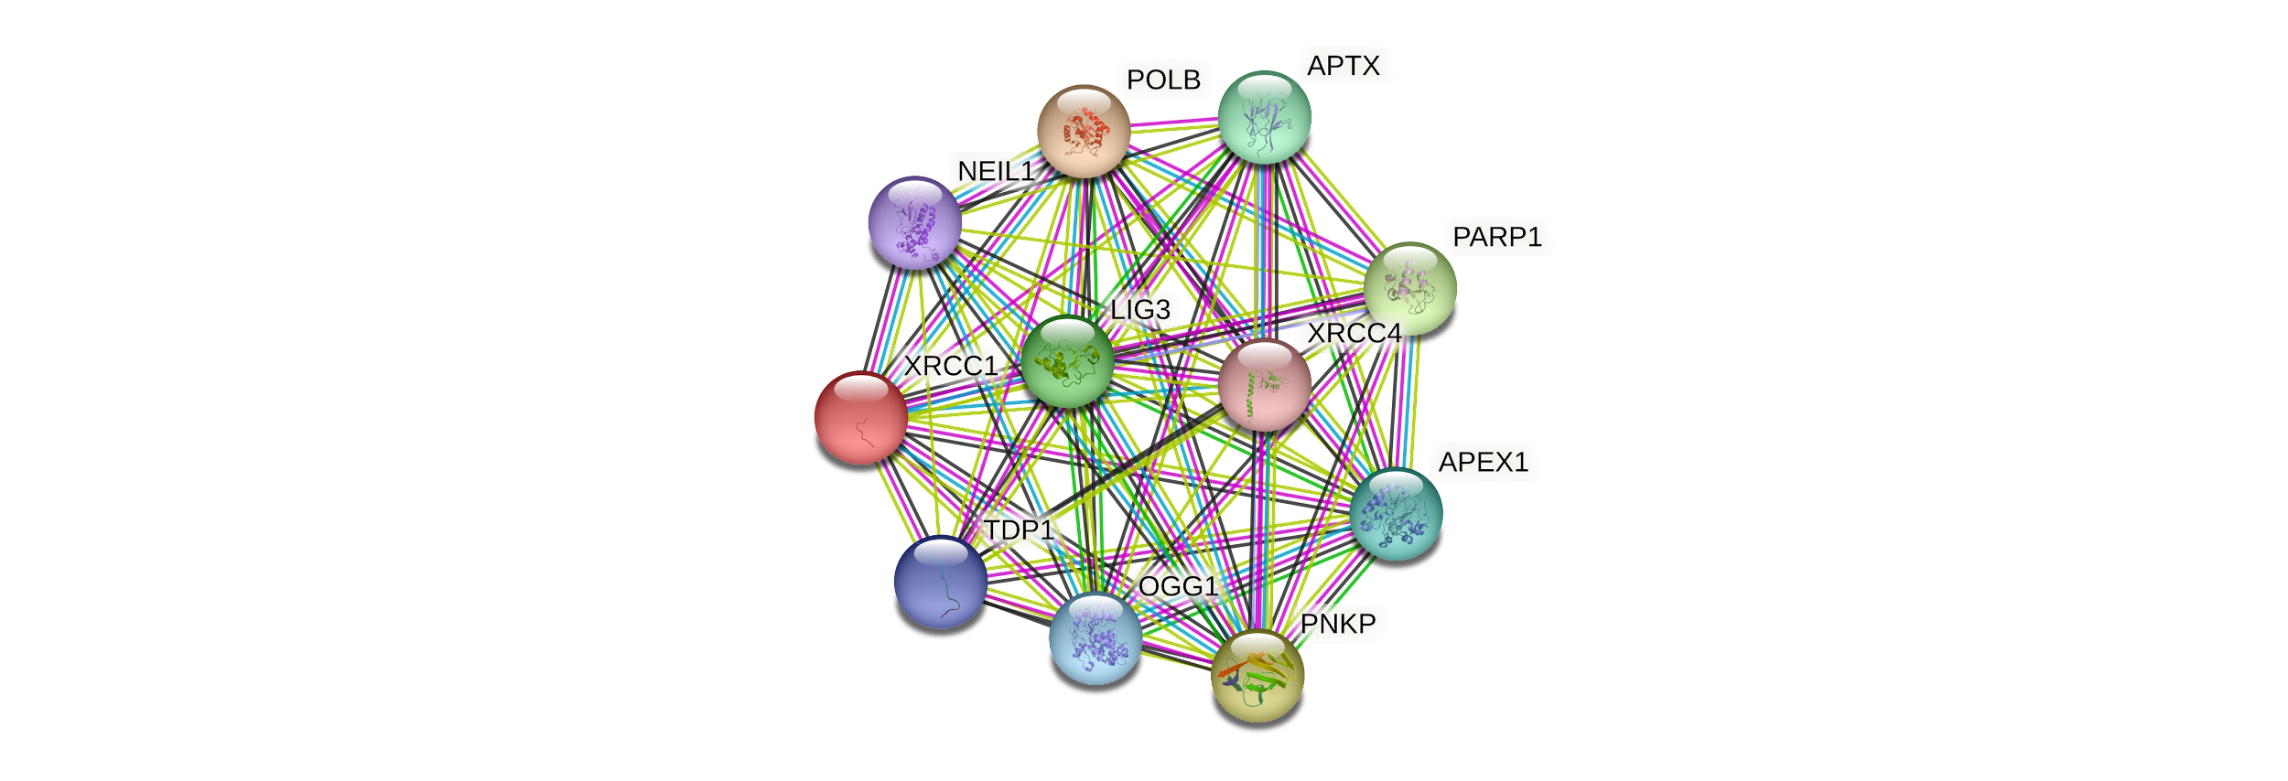

**Figure S25:** Protein-protein interactions of XRCC1 using STRING database